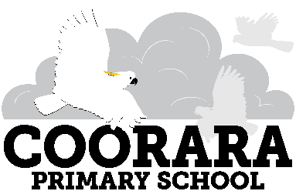

Family Information
2021
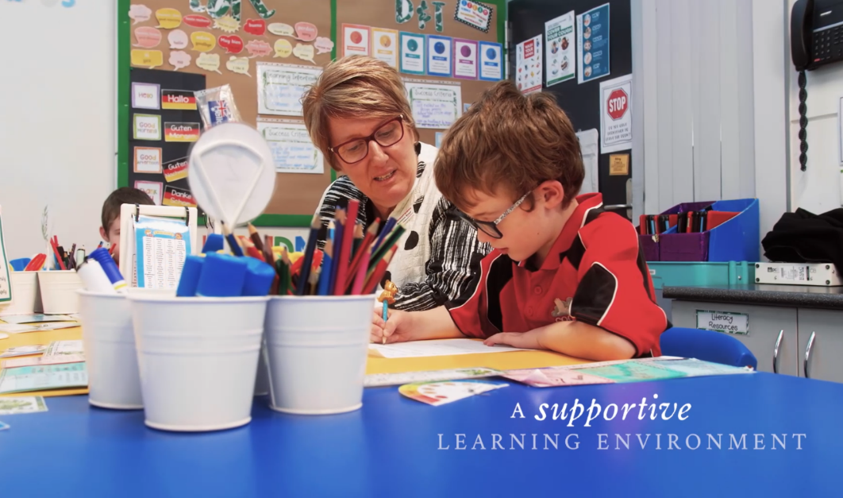

Coorara Primary School Vision

Building a community of curious, creative, resilient and open minded learners

We acknowledge the Kaurna people as the traditional custodians of the land upon which our School is situated.
Scan QR Code
to Coorara PS
Website

Contents
School Banking | 16
School Card | 16
School Fees | 16
School Sport | 16
School Uniform | 16
School Uniform Purchases | 17
Special Needs | 17
Sports Day | 17
Student Wellbeing | 17
Transition | 18
Values | 18
Volunteer Training | 18

Leadership Team | 4
Dates for 2020 | 6
School Times | 6
Absenteeism  Acknowledging Students | 6  7
Assemblies | 7
Attendance  Better Behaviour Better Learning  Bullying Prevention Policy | 7  7  7
Canteen | 8
Choir | 8
Collection/Dropping off of Students | 8
Computer Facilities | 9
Crunch and Sip | 9
Dental Clinic | 9
Education Program | 9
Emergency Contact Form | 10
Emergency Lunches | 10
Emergency Sirens | 10
Governing Council | 10
Hats: Sun Safe | 10
Health Support | 11
Home/School Communication | 12
Hot Weather  House Systems | 13  13
In School Performances | 14
Lost Property | 14
Mobile Phones | 14
Money Collection | 14
Money and Valuables | 14
No Smoking | 14
OSHC | 14
Parent Complaint Policy | 14
Parental Involvement | 15
Reporting to Parents | 15
Resource Centre | 16

Leadership Team

Rebecca Read
Principal
rebecca.read360@schools.sa.edu.au

Donna O’Leary
Deputy Principal
donna.oleary175@schools.sa.edu.au

Dianne Hendy
Business Manager
dianne.hendy537@schools.sa.edu.au

Dates
for 2021
Term 1
Wednesday 27 January – 9 April

Term 2
Wednesday 28 April – 2 July

Term 3
Tuesday 20 July – 24 September

Term 4
Tuesday 12 October – 10 December

Pupil Free Days
Tuesday 27 April
Monday 19 July
Monday 11 October

School Closure
Friday 12th November

Public Holidays

(During School Terms)
Tuesday 26 January – Australia Day
Monday 8 March – Adelaide Cup
Friday 2 April – Monday 5 April Easter
Monday 26 April – Anzac Day Holiday
Monday 14 June – Queens Birthday

School Times
Entry to school 8.30am
Learning spaces open 8:40am
School commences 8.50am
Lunch eating 11:30 – 11:40
Lunch play 11.40 – 12.20pm
Recess 2:00 – 2:20pm
Dismiss 3.10pm
Students who arrive after 8.50 am will be marked as late in the roll and need to sign in at the Front Office.
Children are not allowed to leave the school during the day unless collected by an adult and the front office is notified by the parent/carer.

Absentism

Parents can phone the school on 83252066 or SMS to 0418 158 511 or write a note to the teacher in their child’s diary/communication book.

Acknowledging Student Achievement
Students will be acknowledged for their achievements using the Learning Dispositions. Eg Assembly Awards, Class Awards.

Assemblies
Held 3 times a term in the hall on a Tuesday from 2.25 pm. The assemblies are hosted by classes.
Parents are very welcome to join us for our assemblies. They are a real highlight of our school life. A roster publicising which class is hosting each assembly will be advertised in our school newsletter and on the term planner.

Attendance
Our attendance motto is: Be an Attendance HERO (here every day ready on time).
We believe that
- regular attendance enables students to access a full education, enabling them to reach their full potential.
- future student success is determined by regular and on time attendance at school and that parent support in this is paramount in avoiding future truancy.

Parents’ / Carers’ Responsibilities
- Parents/caregivers are responsible for getting their children to and from school.
- Children should be punctual, arriving from 8:30 and in classrooms at 8:50.
- Children should attend school on every day when instruction is offered unless the school receives a valid reason for being absent (eg illness).
- Parents/caregivers must provide school with an appropriate explanation for the student’s non-attendance. If the school has not received notification from the parents /caregivers a SMS will be sent to confirm the child’s absence /lateness. All absences must be explained and the school can request a medical certificate for long or frequent absences.
- When a student is late for school, they need to sign in at the Front Office. Parents /Caregivers need to provide a reason for the lateness.
- Parents / Carers must go to the Front Office to sign out their child before collecting them.
- Parents/caregivers must let the school know if an extended absence is likely or if the teacher can assist parents to provide work at home to support the learning program.
- Apply for an exemption from school for holidays that range in length from one week. The form for this is available from the Front Office.
- Make sure that all emergency contact details, including the parent/caregiver’s mobile telephone number, are up to date.

Better Behaviour
Better Learning

Our golden expectation is that we treat others the way we want to be treated. Our code of behaviour ensures learning time is maximised and respects the rights of all to be safe.

Scan QR Code to view the full version of the code of School Behaviour Policy

Bullying Prevention
At Coorara Primary School we believe that all students have the right to a safe, inclusive and supportive learning environment. Bullying, including cyber bullying; harassment and violence, is unacceptable behaviour. Bullying and harassment are issues that are treated very seriously as they can adversely affect a person’s ability to work and learn, therefore we work hard to find solutions to stop incidents from occurring.

For more information please read our Bullying Prevention Policy.

Scan QR Code to view the full version of CPS Bullying Prevention Policy.

Canteen
Students can order lunch from Adam’s Deli on Fridays.
4 EASY STEPS FOR ORDERING LUNCH WITH ADAMS DELI
Step 1. Write your child’s name, room number and unit on either a snap lock bag or paper bag
e.g Molly Smyth, Room 5, Green Unit
Step 2. Add your order to the bag
e.g 1 x hot dog with butter and sauce $4.20
1 x banana $1.20
Step 3. Add up the cost of the items and place the money in the bag. (Change will be given)
$4.20 + $1.20 = $5.40
Step 4. Place the order in the box provided in the front office no later than 9:15am
Children’s University
Our students have the opportunity to be involved in an exciting program: ‘Children’s University Australasia’ (CUA).
CUA aims to encourage high quality out of school hours activities for children aged between 7 and 14 years, engaging the wider community as learning partners in this process. The most important principles of CUA are that participation is voluntary and activities must take place outside the normal school day during lunch, after school, weekends and holidays.
In partnership with The University of Adelaide, we aim to raise aspirations and develop a love of learning by issuing students enrolled in CUA with a ‘Passport to Learning’ which records their individual learning journey. After 30 hours of learning, the children are rewarded for their participation with certificates at a graduation ceremony to be held at the University of Adelaide.
Choir
Coorara Primary School has two choirs, a senior choir and a junior choir. The Senior Choir is involved in the Primary Schools Festival of Music.

Collection/Dropping off of students
There are NO parking facilities or collection/drop off points available within the school grounds immediately before or after school i.e. 8.30 – 9.00a.m. or 2.30 - 3.30p.m. Parents are asked to park on adjacent roads and walk into the school grounds. If picking up or dropping off your child at other times you are welcome to use the visitor's car park adjacent to the front office.

Computer Facilities
We have a 1:1 iPad program. All students are provided with an iPad to use at school. Students have access to Lap tops.
Crunch and Sip
Coorara is a Crunch & Sip® school, to support students to establish healthy eating habits whilst at school. All classes enjoy a Crunch & Sip® break and eat fruit or vegetables and drink water in the classroom every day.
Dental Clinic
All primary aged school children are able to access free dental care. Coorara students utilise the School Dental Clinic located at 2 Alexander Kelly Drive Noarlunga. Please call them on 8384 9244 if you have any enquiries. They are open Monday – Friday, 8.30 am – 4.30 pm
Educational Program
All South Australian schools teach the Australian Curriculum.
A broad and balanced curriculum is offered at Coorara Primary School to all students in each of the following Areas of Study: -
English
Mathematic
The Arts
Music and Drama (taught by a specialist teacher)
Health and Physical Education (taught by a specialist teacher)
Science (taught by a Specialist teacher)
History
Geography
Digital Technologies
Spanish
At the beginning of each term class teachers send home a term overview outlining what will be taught in each of the curriculum areas.

Emergency Contact Forms
Parents are required to update emergency contact information at the start of each year or when details change.

Emergency Lunches
Student who for any reason do not have lunch will be provided with either a cheese or vegemite sandwich.

Emergency Sirens

At Coorara Primary School we have three different sirens that indicate an emergency situation. If one long continuous blast of a siren is made over a 30 second period it informs everyone in our school (students, teachers, parents, visitors, contractors) that we need to leave our location and move towards the oval.
If repeated, short rings of the siren are made for 30 seconds, it informs everyone in our school (students, teacher, parents, visitors, contractors) that we need to stay inside in a safe, secure building. This siren would typically alert everyone that a serious situation was evident. (Vicious dog/animal, extreme weather, dangerous intruder etc).
If a five second blast of the siren, followed by a short blast of siren are made, it informs everyone that we need to evacuate off site and move towards Frank Court (shopping centre on Taylors Avenue)
As a school we regularly practise both procedures to ensure that everyone knows what to do in either situation. If you are in our school, when either of these sirens sounds, please respond appropriately. Parents are notified by SMS after a practise has occurred.

Governing Council
The Governing Council plays an important part in the management and development of our school. It is responsible for ensuring that the community’s wishes and ideas are incorporated into the schools educational program, and is a key body in school decision making.
A new Governing Council is elected at the Annual General Meeting in Term 1. Governing Council meetings are held twice a term on a Monday night from 7.00pm. All interested parents are welcome. These meetings are conducted in a relaxed and friendly atmosphere. You are also invited to raise issues of interest or concern to you through your Council representatives. Dates of meetings are advertised in the fortnightly newsletter.

Hats: Be Smart Wear a Hat

All students are required to wear a sunsafe school hat (wide brimmed or bucket hat) while outside during the school day in term 1, 3 and term 4. Students who do not have a hat are asked to stay under solid shade School hats are available for purchase from the Front Office.

Health Support
Coorara Primary School is committed to supporting the health and well-being of all students. Parents/carers retain primary responsibility for their child’s health care. This includes responsibility for providing accurate, up-to-date relevant information to staff regarding their child’s routine and emergency health care needs. The school does not have the facilities or skills to care for sick students other than to provide first aid. Students who are ill should rest and recover at home until they are well enough to return to school.

Accidents or Illness

Our staff are trained in basic first aid. Staff will provide an initial assessment and first aid treatment to students. The school will contact parents and carers to make a final decision about seeking further medical advice or treatment.
In the event of an accident or illness, you or your nominee will be contacted as soon as possible by a Staff member. If a child requires emergency treatment, an ambulance will be called.
Medication Management

Where possible, we encourage students to take medication outside of school hours. If medication is necessary at school, students will be supervised in managing this process themselves or will be given the medication by front office staff.
- Medication must be provided in the original pharmacist container with directions on the label
- The child’s name must be on the original label
- Medication must be stored safely and so needs to be taken to the front office and given to a front office staff member for storage in a secure cupboard. This should be handed from adult to adult.
- Students must have a medication plan filled out by a doctor and the parent/carer
- A maximum of a week’s supply is to be provided at any time (except asthma medication)
- It is the parents/carers responsibility to provide the medication.
- A medication log will be filled out by the front office staff member supervising or giving the medication.
- Epipens must be replaced once out of date.

Routine Health and Personal Care Support

Some students may require assistance with their routine or emergency health and personal care needs. Before staff can assist with this, parents/carers must provide written information from their doctor who outlines specific care needs and needs updating every 12 months. Forms are available from the front office for a range of health conditions and needs, including:
- Asthma
- Diabetes
- Anaphylaxis (severe allergy)
- Medical information (for General health care or those without specific forms)
- General health information (to be completed by a general practitioner, psychiatrist or psychologist)

The purpose of these health care plans is to ensure that the school has information from the treating health professional relevant to the student’s health, well-being, attendance, learning and care at school. We can write a ‘health support plan’ for the child if deemed necessary by the school or if any of the following are relevant
- There are any individual first aid requirements, other than a basic first aid response
- The child needs additional supervision for health related safety
- There is a predictable need for additional support with daily living tasks

Health support plans are written using the written information from the treating health professional, with discussion between school staff and the parent/carer.

Asthma

Students with asthma (even if only ‘mild’ or ‘occasional’) need an asthma care plan completed and signed by the treating doctor and given to the front office staff. Asthma Care Plans need to be updated every 12 months. Staff can remind students to take their preventative asthma medication prior to physical activity if this is part of the asthma care plan. Staff are also trained to administer reliever medication in the event of asthma attack. The school has reliever medication for use in emergency situations only. All students who require asthma medication must have puffers in the front office. All asthma puffers must have the pharmacist label, including the student’s name, stuck on the puffer.

Infectious Diseases

Please contact the school if your child contracts an Infectious Disease and you are unsure of the period of exclusion from school.

Home / School Communication

Ongoing communication between home and school is essential as we work together to support the development of your child. At Coorara Primary School we use a range of communication forms between home and school including:
- school diary or communication book term overview and class newsletters
- Coorara School App (Skoolbag)
- Coorara school community facebook page
- See Saw
- School Newsletter published fortnightly

Our School Newsletter can be accessed by
- Us emailing it to you
- Hard copies available from the Front Office and the Resource Centre
- Facebook
- Skoolbag app
- Coorara primary School Website

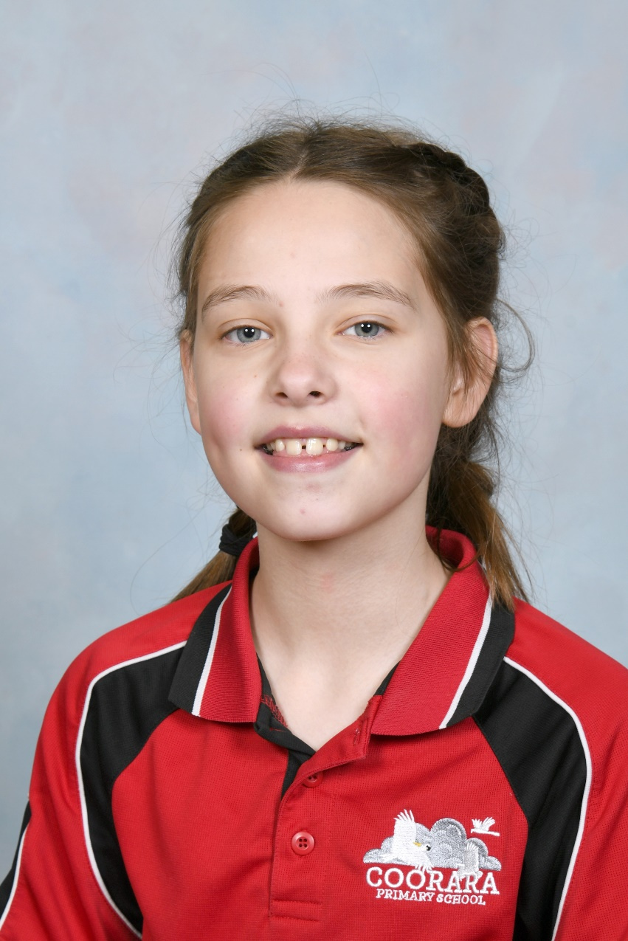

Hot Weather

All classrooms at Coorara are equipped with air-conditioning, which provides students with a cool environment in hot weather.
Our Policy will operate on days when the estimated forecast as given in the media is above 36°C, depending on local conditions at Noarlunga.
LUNCHTIME AND RECESS PROCEDURE
- No sports equipment will be issued and/or used.
- Oval will be closed
- Resource Centre will be open. All children will be expected to stay in the shade.

On days of extreme heat, when the estimated forecast as given in the media is above 38°C, at Noarlunga, students will stay inside during lunchtime & recess.

House Systems
At Coorara Primary School there are 3 Houses – Cockatoo (Yellow), Rosellas (Red) and Kookaburras (Blue). Staff and students are assigned to a house.
The aim of the House System is to integrate our school values with mentoring, peer support, student well-being and encouraging students to have interactions and friendships that transcent to different year groups while providing opportunities for student leadership.
The House structure is a combination of Heads of House, four House Leaders that are representatives from Years 5,6 and 7 and then two House representatives from reception to Year 5.
There is a House point system where students are awarded points for achieving learning goals based on the learner dispositions, showing evidence of our school values and on sports day.
Throughout the year the houses have regular House meetings to organise fundraising, whole school/ house activities and events.

In School Performances

The school organises three Incursions a year. The school pays for the incursions, no charge to families. Information about incursions will be communicated in the School newsletter.

Lost Property

We ask parents to label all students clothing and personal belongings. Check the rack located on the southern side of the Front Office for any missing items.

Mobile Phones

Students who bring a mobile phone to school must keep it turned off and hand it to their teacher each morning. The school takes no responsibility for mobile phones that are brought to school and become lost, stolen or broken. It is highly recommended that mobile phones are not brought to school.

Money Collection

The cashier office is located on the courtyard side of the Administration Office and is open for collection of money from 8:30-9:00 on Monday & Fridays, then 2.45 pm – 3.15 pm on Tuesday, Wednesday & Thursday. We have a drop and go box which is situated in the front office.

Money and Valuables

Please do not allow your child to bring to school unnecessary amounts of money or valuable articles. The school takes no responsibility for the loss or theft of any money or valuables brought to school.

No Smoking

Government Regulations state that our buildings and grounds are a no smoking zone.

Coorara Kids OSHC offers Before School Care (7:45-8:30am) and After School Care (3:10-6:15pm). Vacation care is also available, vacation hours 7am – 6pm). Coorara Kids OSHC is located in Room 1 in the yellow unit. The OSHC Director is Debbie Hutchinson. For further information please see the Coorara Kids OSHC family information booklet available on our school website or from the Front Office.

Parent Complaint Policy

We all expect quality and expert care and teaching for your child in order that they achieve their potential. Working together will give us the best chance of solving a problem that may arise during your child’s years in school. We also recognise that at times things may go wrong. If you have a concern or a complaint, we want you to let us know. It’s important to learn from mistakes or misunderstandings so that we can improve your child’s experience and learning, and also improve processes where possible. The first step in working through a complaint is to talk to your child’s teacher, and then the Principal if you still are not happy. A copy of the school Parent Guide to Raising a Concern or Complaint brochure is included in the parent information folder or ask at the front office. Steps guiding how complaints should be made are explained in the brochure.
Parent Involvement
Parents are welcome in our school and can be involved in so many ways. Such association benefits your child by giving him/her experience in relating with a number of adults and also can be most rewarding to the parents involved. If you are interested in volunteering here are some ways of being involved:

- Help in the library
- Help in the classroom, hearing children read, reading to children, assisting individual children to learn tables, taking small groups for cooking or crafts, and offering assistance
on excursions
- Attend school functions
- Offer your expertise - the experience and talent in the parent community is enormous
- Help manage, coach or transport sports teams or come along to support your child’s team
- Nominate for Governing Council or a sub committee

Reporting to Parents
The student reporting structure is designed to provide parents with regular opportunities to view and discuss their child’s progress during the year.

Leader Led Conversations

Leader Led Conversations take place late in Term 1 and optional Interviews are offered in Term 3. Pre interview planner will be sent home prior to the interviews. Leader Led Conversations provide opportunities for open communication between student, parents/caregivers and teachers about the students’ social development, academic progress and behaviour.
Written Reports
A Written Report comes home at the end of Terms 2 and 4 and provides information on student progress in the areas of study and other aspects of schooling, such as attitude and social skills.
Parents are encouraged to make a time to meet with their child’s teacher at any other time to discuss progress or any issues they may be having.

Resource Centre
Our Resource Centre provides a dynamic learning environment for the development of active, independent learners with services and curriculum resources of the highest quality and relevance. The Resource Centre is open daily from 8:30 and is open at recess and lunch.

School Banking
School banking is conducted by the Bank of S.A. and Commonwealth Bank. Enrolment forms are available from the front office.

School Card
The School Card Scheme is administered by DfE and provides financial assistance towards the cost of education expenses to full-time students of low income families. Please see our Business Manager, Dianne Hendy for more information.

School Fees
School fees (Material and Services Charges) for 2021 have been set at $246.00 per student. Parents will be invoiced early in term 1. This, together with our DfE funding, is used to fund our educational programs, stationery and the maintenance and development of school buildings, grounds and resources.
Throughout the school year, teachers may organise camps, excursions, etc.
As these events occur, parents will be notified about the nature of the activity the amount of money that is required and the timeline for payment.

School sport
Coorara Primary School offers a range of competitive sporting opportunities for students in the sports of Basketball, Football, Netball, Soccer and Cricket. Students who are turning 8 in the year of competition or are already 8 years old are eligible to compete. Parents or students who may be interested in playing such a sport are encouraged to speak to our Deputy Principal Donna O’Leary or our front office staff. We are a member of the South Australian Primary Schools Amateur Sports Association (SAPSASA) and Year 5-7 students have the opportunity to participate in many SAPSASA events.

School Uniform
At Coorara we are proud of our learning environment and the sense of belonging to a supportive community.

The sense of identity is developed in students through the wearing of the school uniform. We have a school uniform policy that is strongly supported by students, parents and staff. It is an expectation that the uniform will be worn by the students. We also believe that the school uniform promotes student safety and is practical and inexpensive.
For further information please see Rebecca Read or Donna O’Leary.
We understand that there are occasions when students may not be able to wear the school uniform. In these circumstances please write a note in your child’s diary or communication book. In the interest of student safety students who are not in uniform cannot play on the oval during break times.
Please see our School Uniform brochure for further information, available on our school website and front office.

Please scan QR code to view Website for Uniform Policy 2021

School Uniform
Purchases

Uniform tops and hats can be purchased from the Cashier office.
Monday and Friday: 8.30am to 9.00am
Tuesday, Wednesday & Thursday 2:45-3:15pm
Polo Tops - $24.50
Windcheaters - $33.00
Jackets - $33.00
Hats - $13.00

Special Needs
Coorara offers small group or individual instruction to a number of students who have been identified as having specific learning needs. This is managed by our Deputy Principal, Donna O’Leary. If you have concerns about your child’s learning, social or emotional development, please speak to the class teacher.

Sports Day
Sports Day is held annually in term 3. Students participate in a range of Tabloid events and a range of field events. Sports Day teams are:

Kookaburras - Blue
Cockatoos - Yellow
Rosellas - Red
Student WellBeing
A major emphasis is placed on providing a safe, supportive learning environment free of harassment for all community members. Students are taught skills to help them feel safe, including telling an adult if they are harassed or bullied. For further information please talk to our Student Wellbeing Leader

Transition
Reception students who will be enrolling at Coorara Primary School to begin their schooling will be involved in the Coorara Cubs Program. Information is available from the Front Office and in the Parent Information Folder.

Values
Coorara Primary School is a school community that values
- Caring
- Honesty
- Respect
- Responsibility
- Teamwork
As a community we promote the importance of what these values stand for and encourage our students to behave in a manner to reflect these values.

Volunteer Training

All parents and community volunteers who work in the school must undergo training. Volunteer training sessions are held throughout the year. Dates and times of Volunteer Training sessions will be advertised in our school newsletter and on the school app.

