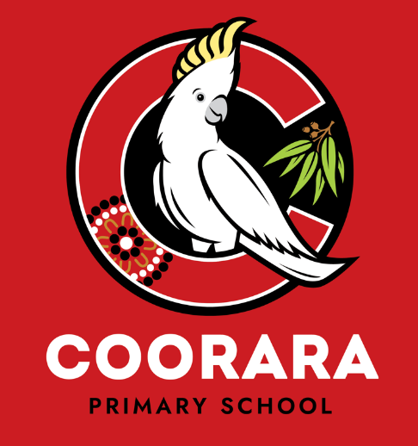

**2024 Report to School Community**

**Presented at the AGM on 12 February 2025**

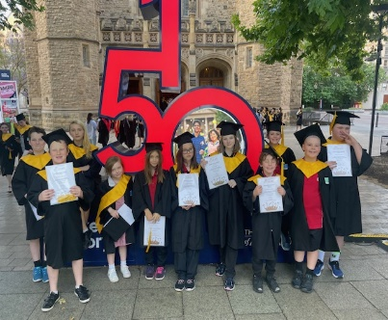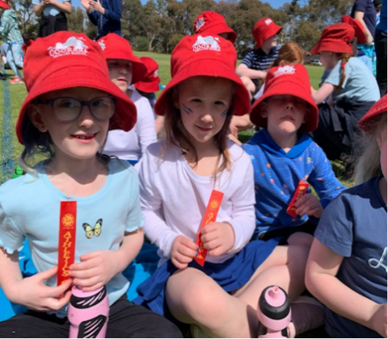





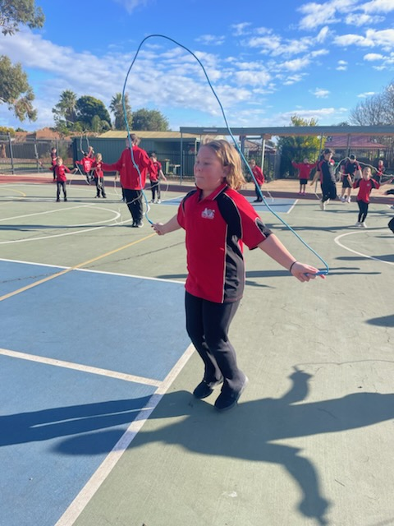

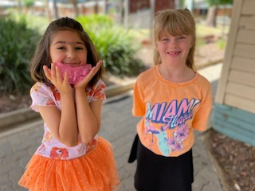

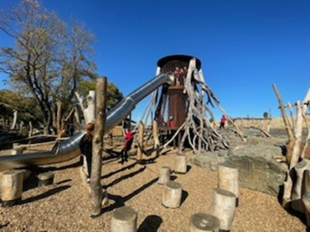

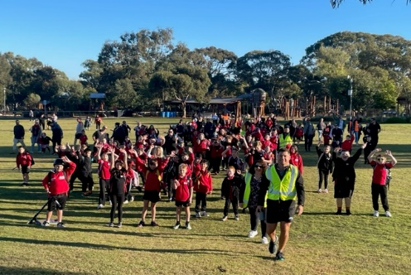

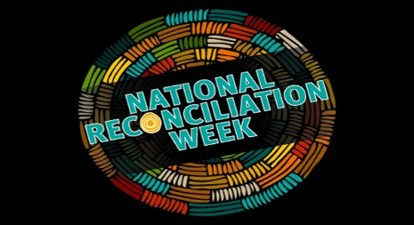

***Our Vision: Build a community of curious, creative, resilient and open-minded learners***

**Principal:** Stephanie Tulloch

**Governing Council Chairperson:** Sharleena Bohn

**2024 Highlights**

We started the year with 219 students and ten classes. 27 Reception children started their formal schooling at Coorara in 2025. Joining the midyears and creating a cohort of 42.

There was a change of classes for several teachers as we moved our reception team to the green unit. Our Red unit housed year 1-3 students and blue unit consisted of Year 3-6. Our specialist teachers offered children a double Science lesson, 2 x Health and Physical Education lessons and 2 x Performing Arts lessons each week. The new school year brings changes to our staff team. We are very fortunate to have the following staff starting in new roles:

* We welcomed Christine MacLean into the Wellbeing Leader role at the school for the year, replacing Anthony Parina who was seconded to Reynella.
* Sophie Byrne started a 12-month contract in a Year 2/3 class.
* Zac Schenkel continued with us in a contract in a Year 2/3’s
* Ryan Tilling has joined us from Kangaroo Island as a permanent teacher with Year 5/6 children.
* Sophie Panousakis has returned to us, and started with Year 2 students, team teaching with Laura Lacey.
* Halfway through 2024 we lost Allyson Gear to Brighton Primary. Sophie Panousakis replaced her in literacy intervention and Jess Dyer took Sophies teaching role.

**Soaring for Success** was well supported by our teacher development in Positive Behaviour for Learning, and this was threaded through our beginning year programmes, extending expectations across the school. It made the transition for most students very calm and easy. There was a big focus on ‘Codes of Conduct’ across all rooms, with set expectations for learning.

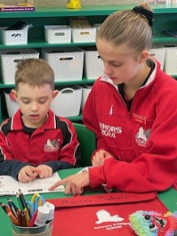Leadership for the Year 6 students started early. All Year 6 students had to create their own resume and apply for a leadership role for the 2024 school year.

Our Community Night, ‘Everything is possible… even the impossible’ was a lovely evening. Mary Poppins themed activities occurred around the playground. It was well attended by so many families, with Children’s University and Smith Family in attendance. The BBQ and the snow cones were a hit, and parents enjoyed seeing what their child’s classroom looked like.

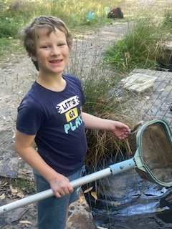  
**Camp:**

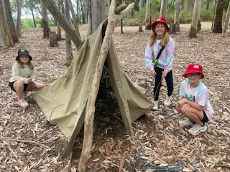 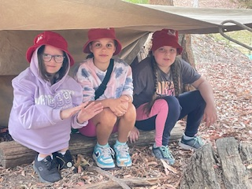 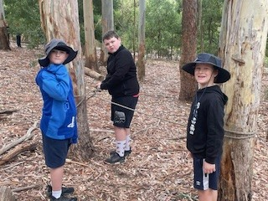

Our Year 4, 5 & 6 Camp to Arbury Park was a great experience. The kids had a lot of fun, and for some it was their first time away from home and families. The experience was well supported with 120 students spending two nights in the Adelaide Hills. Well done and thank you to the staff who made this event happen.

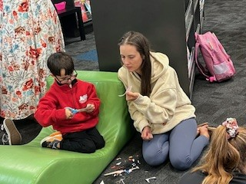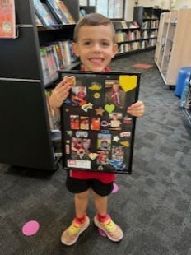**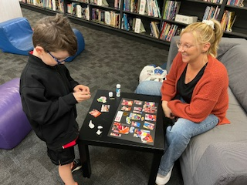Magical Memories:** Reception children invited their families to Magical Memories. The two classes created some lovely pieces of art to take home. It was special to see the family interactions on these nights, with parents gaining much enjoyment from the activity.

**Breakfast Club** There are toast and spreads for children to have every morning, even if it is a second breakfast! Rachael, Kristen and Janette have done a superb job, and Kick Start is behind the programme, supplying us with goodies for our students. **And Bread:** staff collect from Bakers Delight each Monday night, and this is distributed to the community on the Tuesday. It is a wonderful way to support families.

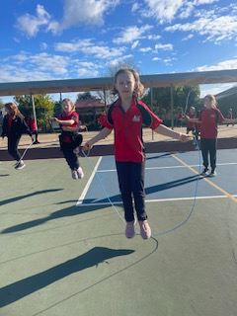

**Jump Rope for Heart:** the whole school was out jumping and skipping and dancing for this event. It was a super afternoon.

**Mother’s and Father’s Day stall**: this was the first year that our fundraising committee was able to support these days and with great success. There are always ways to improve, and we learned over the year, but it was a super initiative for them to start. It was well supported by families.

**WALK TO SCHOOL DAY**: On Friday May 17, parents dropped their children at Wilfred Taylor Reserve, and we all walked to school. It was a beautiful day and all traffic stopped to let us across the roads as we smiled and waved. Breakfast was a sausage sizzle once back at school.

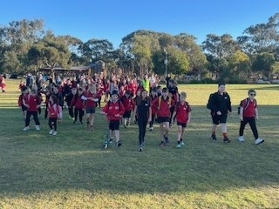 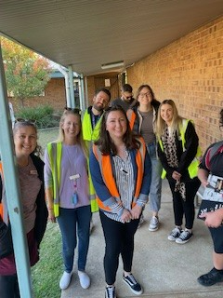 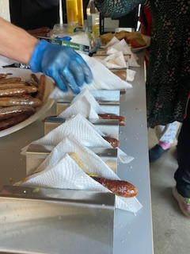 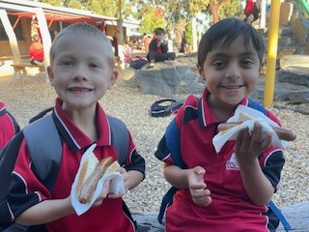

**Play, Create, Connect, and Little Bookworms:** During 2024 we continued to offer two programs for children aged 0-5 and their parents/carers. Children and parents enjoyed stories, songs and rhyme at Little Bookworms. This program promotes strong connections with young families in our community and the importance of early literacy development. C:\Users\O'learyD\AppData\Local\Microsoft\Windows\INetCache\Content.Word\play-create-connect-logo-large.png playgroup was held weekly in room 5 and 6 had many families attending. It was a great way to showcase Coorara Primary. There have been charges for 2025.

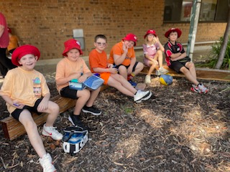**Harmony Day** was celebrated in March with a community sausage sizzle and a touch of orange! Children celebrated how all our differences make Australia a great place to live. Classes all got into the spirit of things, with activities occurring in all rooms.

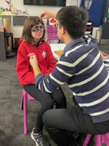**Itya­mai­it­pin­na Yarta, Glenthorne National Park excursion, celebrating NAIDOC Week**: we had a superb excursion to Glenthorne National Park. The children played, did history walks and enjoyed a picnic lunch. It is such a valuable place to have on our doorstep and we will continue to return.

**OPSM:** this was an interesting venture for us with contact made by OPSM to test students’ eyesight. Many children needed glasses, and these were supplied free. It was a tricky process, and not the smooth sailing we hoped for though.

**Story Dogs:** Anne and her little dog Bertie came to join us on Thursdays in the library. Bertie is a story dog and is part of a programme to assist children with their confidence in reading.

The move to **Education Management System (EMS)** wow, this was an eye opener as we made the change to the new DfE administration system. It definitely caused a few grey hairs, however we have persevered and been successful. The parent portal aspect is taking a lot longer to get up and running though.

**‘Lock-In’ is** a night full of laughter, noise, fun and games that has been held annually, and this year was no different. Lots of children attended and staff supervised for the evening.

**Parent Information Night:** We organised Bill Hansberry to present **‘Get off that Computer!’** in August. It was an evening session, and we offered free childcare and food for families. We were forced to cancel the evening due to lack of interest which was very sad. It is interesting to note that we get several calls every week from parents asking up to support them and their children in getting off the computer / phone / apps / sites, and online bullying that occurs over the weekend. This parent session could have been very valuable to address all these issues.

**PBL:** Coorara Primary has been involved in Positive Behaviour for Learning (PBL) over the last 18 months, led by Lisa Carthy and her PBL Team. All staff have been working hard to create expectations around school expectations and we are seeing positive change across the school.

Our Values for all students, staff and community are to be ‘Respectful, Responsible and Safe’ at Coorara Primary. New signs and expectations for behaviours have been advertised around the school. Children have been explicitly taught, and we are seeing the benefits of the program.

**Festival of Music** – Nikki Bridgman is such an asset to our school. She works tirelessly in the performing arts, and this year we sent our choir to represent our school in the Festival of Music in September. The **Performing Arts** program is a point of difference for our school in the local community. In 2024 the school performed Mary Poppins. Other Performing Arts opportunities included the string ensemble, Junior Choir, Senior Choir, Rock Band and excursions. Jam Band came and entertained us. Classes participated in two performing arts lessons per week with our specialist teacher.

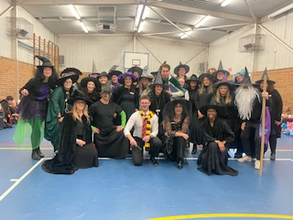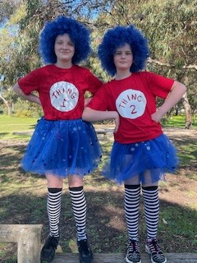**Book Fair and Book Week**:

Every year the book fair is a huge success, with children loving to be able to look at a range of books and toys and take lists home to parents!! Parent support is always strong and in 2024 the Book Week parade was well supported and the kids looked fabulous. We raised more money than other years.

**World Teachers’ Day** was celebrated on Friday, 25 October. We had a special celebration for our teachers with a whole-school picnic in the courtyard. Some children also spoiled their teachers on the day. Our staff at Coorara are one in a million and they work tirelessly for the students and families in the school.

**Halloween Disco** was held on the Friday prior to Halloween. Children all came dressed up for a night of dancing, nibbles and fun. Forgetting to turn off the sprinklers was hilarious and soaked a few unsuspecting kids. Our fundraising committee worked hard organising decorations, groovy music and tasty nibbles packs for students. It was a good night, however there were some challenges. It will be reviewed for 2025.

During 2024 students had the opportunity to participate in several **sporting experiences** including the Sporting Schools Program, Sports Day, aquatics, swimming and weekly PE lessons with a specialist teacher. Several students represented the school by participating in **SAPSASA** events such as **District Athletics Day.** Coorara participated in the **Premier’s Be Active Challenge**, it was a great to see so many students achieving an award and being physically active.

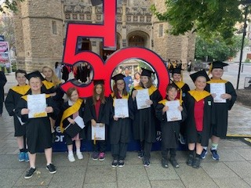**Children’s University Graduation** was held on the 7 November, where 11 of our students graduated with their diplomas. It is such an exciting program for students, and really gets them to experience what Adelaide has to offer outside of school and home. It was wonderful to celebrate some of the students’ learning journeys at the ceremony at Bonython Hall. With the support of their families, they actively participated in a wide range of learning experiences outside of school and visited many learning destinations across the city. Thank you to Christine MacLean and Karina Carlisle for supporting the students’ learning journeys.

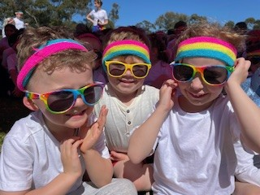**Sports Day** was early in the year, held on the 28 March.

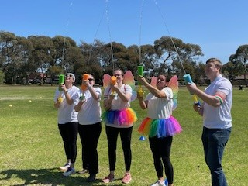**Colour explosion** on 27 September was well represented, and we had some great fundraising for the event. The kids had a great time running the track, and I believe the staff had even more fun. Well, done to Daniel Mills and his committee for the success of it.

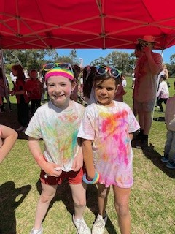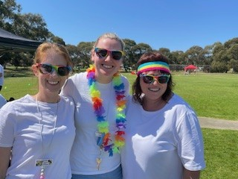

Basketball continued for the school, with Courtney Watt and Sophie Byrne coaching teams. They practised during the week, and we watched them go from strength to strength. It is great to be out in the community representing our school.

We share a positive relationship with the **Coorara Preschool.** Room 7 and Room 8 took on the Buddy Class role which is fabulous. Preschool and school children enjoyed learning in the community garden and looked after the much-loved chooks!

**‘Ready for Reception’** is our newly revamped preschool to school orientation program. The program ran twice last year as we were beginning our midyear intake. It ran over three days. The children experienced many aspects of school life, met staff and met their classmates. All children received a Starting School Showbag.

**Graduation:**

Always a great night – the Year 6 Graduation, held on 12 December. I am always amazed and possibly a little emotional when I see our senior students all dressed up and speaking about their peers. I am quite humbled by their memories of their school life. There was a change this year with a number of awards being given out for our specialist subjects, celebrating our students who gave it their all over their schooling. Brianna Price and Ryan Tilling pulled out all the stops to make it a night to remember.

**Swimming and Aquatics:** Year 6 students attended Aquatics at Port Noarlunga and Receptions to Year 5 attended a weeks’ worth of swimming lessons at Noarlunga Pool. They are always exhausting yet great events. 2025 will be interesting to work through for swimming as the pool is under construction.

**Big Day Out:** such a fabulous day out for the kids, movies and the park. Funding from Variety Club for buses made this such an affordable thing to do.

**AUSLAN**: is our choice of language other than English. It is taught in all classes across the school, with a dedicated time each staff meeting to work with staff on new signs. It was under review towards the end of the year with staff feeling that we were not completing the program with as much efficacy as we wanted, and we have looked into new options for 2025.Watch this space.

